Pontiac Sunfire 4 Dr. Touring Car Racecar: This was our prototype development car for the NATCC, This 4 door Sunfire has an extensive roll cage, the suspension is completely coil-over Bilsteins, adjustable swaybars, Vette 13" brakes and HD wheel bearings and hubs. This car has great potential for a number of racing classes. Inquire if you want to build the ultimate Sunfire racecar- willing to trade for other vehicles, race cars, motorhomes, etc.?
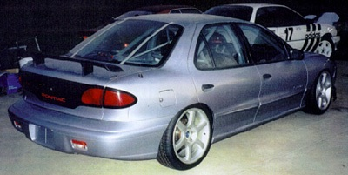
http://www.mantapart.com/misc.html

