Dodge Stratus Super Touring

Model, text, and photos by Sean Svendsen
This is a replica of the Stratus that Dodge sponsored in the short lived NATCC. The car was modeled as it ran at mid-ohio in the summer of '97. I built the car from a Brookfield Collectors Guild promo.
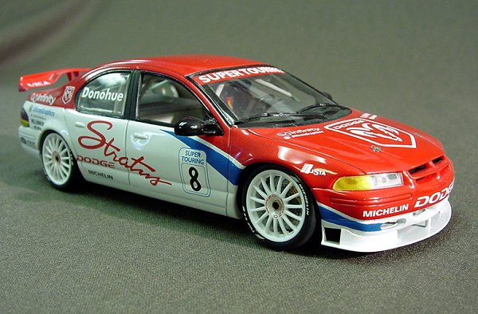
The body was removed of some trim. The front air dam was built from sheet styrene. The unique rear wing was made by building a buck from modeling foam board and than vacu-forming the shape.
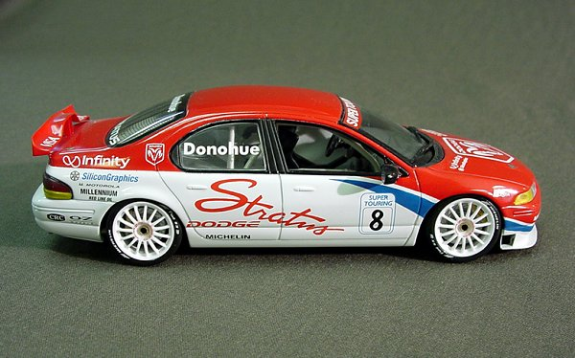
The roll cage was scratch built and the majority of the other parts came from the Tamiya Alfa Romeo touring car kit. The graphics were all created on the computer used to make custom dry transfers.
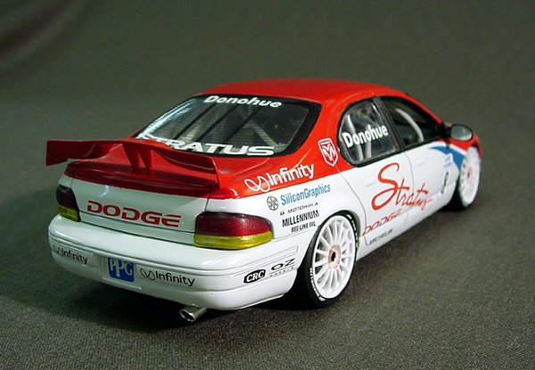
Many thanks to Sean Svendsen for sharing this unique replica.
http://www.gpma.org/Archive/ssdodge.html

