•
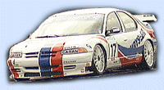
6 Nov - Touring, Touring, Touring...
Well, Touring Cars are getting popular, now a sim based on the Swedish Touring Car Championship will be available in mid Nov. Old NATCC fans will see what happened to the PacWest Racing Dodge Stratus, as they are racing in the STCC. There will be 6 tracks, including the REAL version of Mantorp Park, and Artic Circle Raceway, which according to our Norway Mirror Admin Goy...is a superb new racetrack. Digital Illusions and Bonnier Multimedia are producing the sim, which will be released in Europe only. Time to find friends in Scandanavia...
http://www.thenorwaypits.com/2000_01/main.html

